PRACTICAL NO 3: Configure AAA Authentication on Cisco Routers
To provide a centralized management system for the authentication, authorization and accounting (AAA framework), Access Control Server (ACS) is used. For the communication between the client and the ACS server, two protocols are used namely TACACS+ and RADIUS.
TACACS+
Terminal Access Controller Access Control System (TACACS+) is Cisco proprietary protocol which is used for the communication of the Cisco client and Cisco ACS server. It uses TCP port number 49 which makes it reliable.

RADIUS –
Remote Access Dial In User Service (RADIUS) is an open standard protocol used for the communication between any vendor AAA client and ACS server. If one of the client or server is from any other vendor (other than Cisco) then we have to use RADIUS. It uses port number 1812 for authentication and authorization and 1813 for accounting.
TACACS+ | RADIUS
Cisco proprietary protocol | open standard protocol
It uses TCP as transmission protocol | It uses UDP as transmission protocol
It uses TCP port number 49. | It uses UDP port number 1812 for authentication and authorization and 1813 for accounting.
Authentication, Authorization and Accounting is separated in TACACS+. | Authentication and Authorization is combined in RADIUS.
All the AAA packets are encrypted. | Only the passwords are encrypted while the other information such as username, accounting information etc are not encrypted.
Preferably used for ACS. | used when ISE is used
It provides more granular control i.e can specify the particular command for authorization. | No external authorization of commands supported.
TACACS+ offers multiprotocol support | No multiprotocol support.
Used for device administration. | used for network access

Similarities –
The process is start by Network Access Device (NAD – client of TACACS+ or RADIUS). NAD contact the TACACS+ or RADIUS server and transmit the request for authentication (username and password) to the server. First, NAD obtain username prompt and transmit the username to the server and then again the server is contact by NAD to obtain password prompt and then the password is send to the server.
The server replies with access-accept message if the credentials are valid otherwise send an access-reject message to the client. Further authorisation and accounting is different in both protocols as authentication and authorisation is combined in RADIUS
Advantages (TACACS+ over RADIUS) –
- As TACACS+ uses TCP therefore more reliable than RADIUS.
- TACACS+ provides more control over the authorization of commands while in RADIUS, no external authorization of commands is supported.
- All the AAA packets are encrypted in TACACS+ while only the passwords are encrypted in RADIUS i.e more secure.
Advantage (RADIUS over TACACS+) –
- As it is open standard therefore RADIUS can be used with other vendors device while because TACACS+ is Cisco proprietary, it can be used with Cisco devices only.
- It has more extensive accounting support than TACACS+.
We use the following Topology for the present case

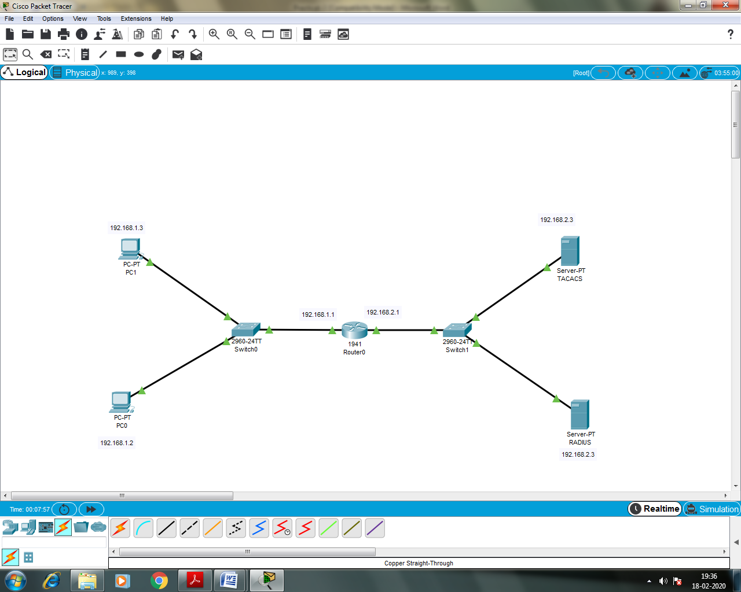
Configuring PC0
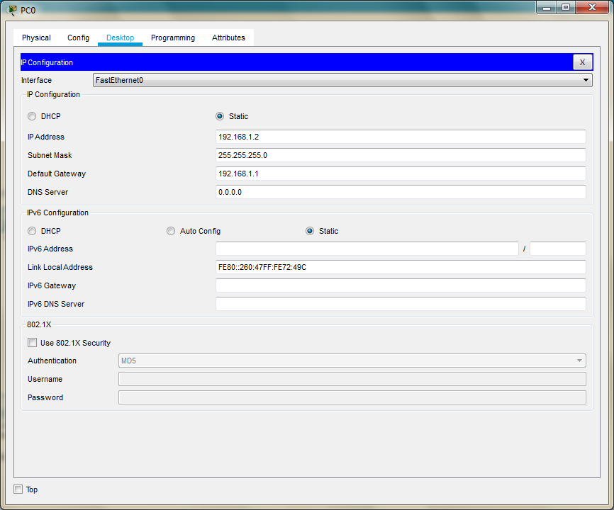
Configuring PC1
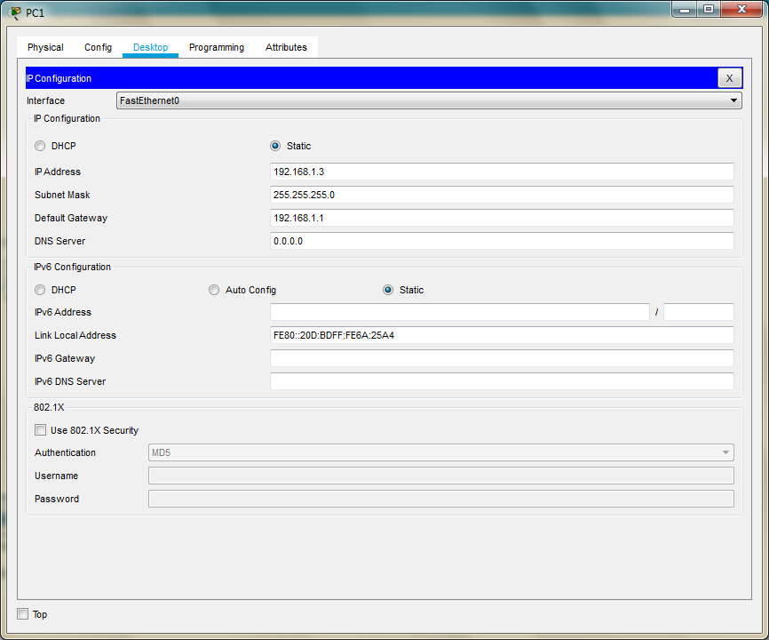
Configuring Router0
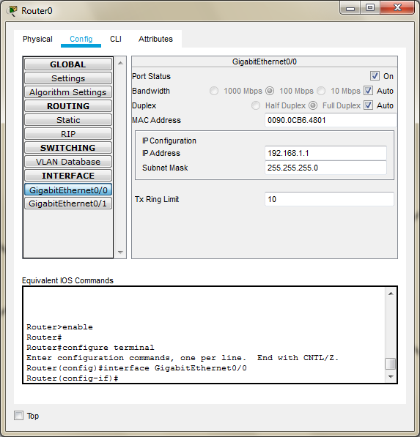

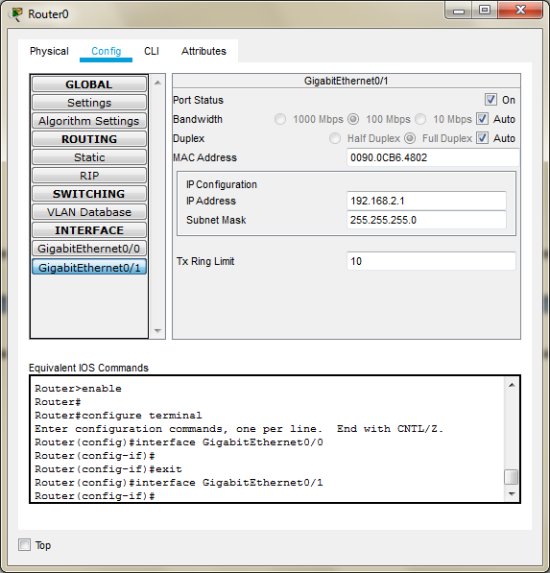
Configuring Server0 (As TACACS)
While configuring the TACACS/RADIUS server the Client IP address must be the Router IP
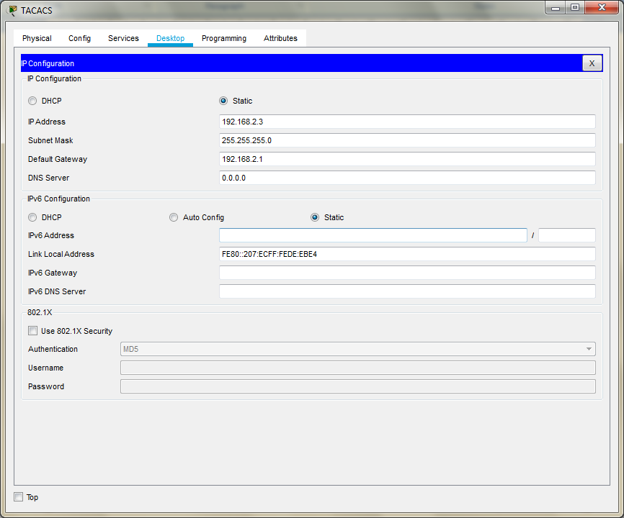
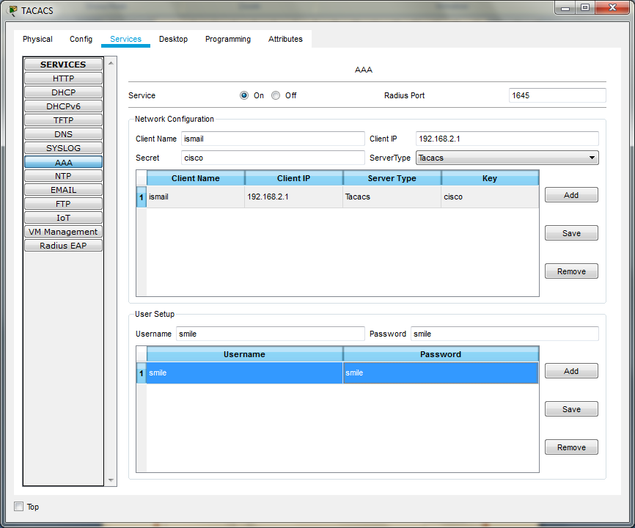

Configuring Server1 (As RADIUS)
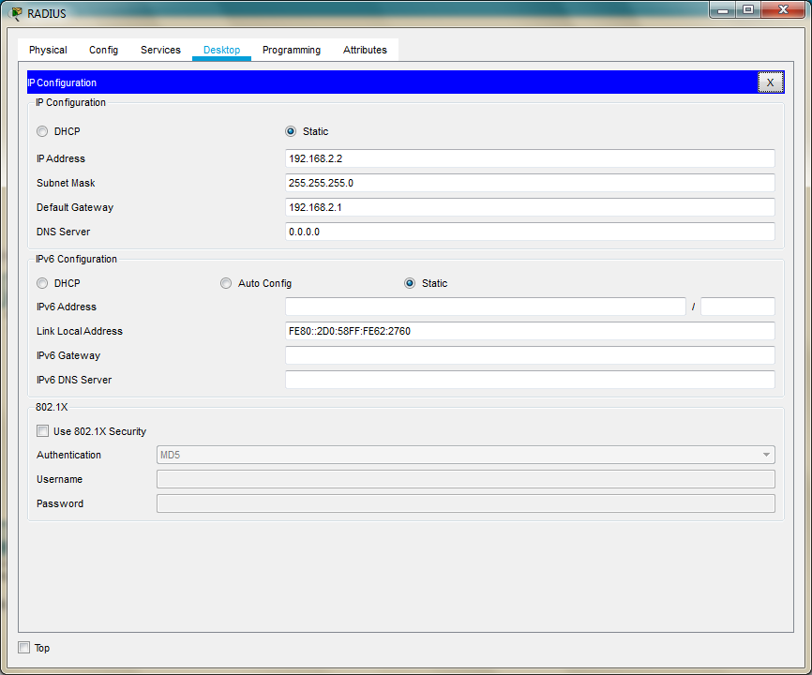

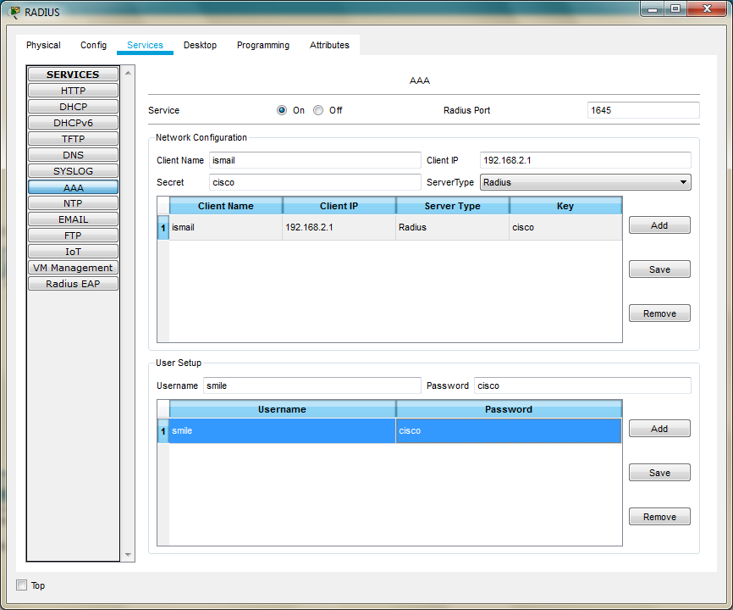

Type the following commands in the CLI mode of the Router0
Router>enable
Router#configure terminal
Router(config)#aaa new-model
Router(config)#tacacs-server host 192.168.2.3 key cisco
Router(config)#radius-server host 192.168.2.2 key cisco
Router(config)#aaa authentication login ismail group tacacs+ group radius local
Router(config)#line vty 0 4
Router(config-line)#login authentication ismail
Router(config-line)#exit
Router(config)#
The Authentication can be done by typing the command telnet 192.168.2.1 (the Router IP) in any of the PCs
We get a prompt to type the username and password, the username and password set in TACACS are entered
Username: smile
Password: smile
We get the following
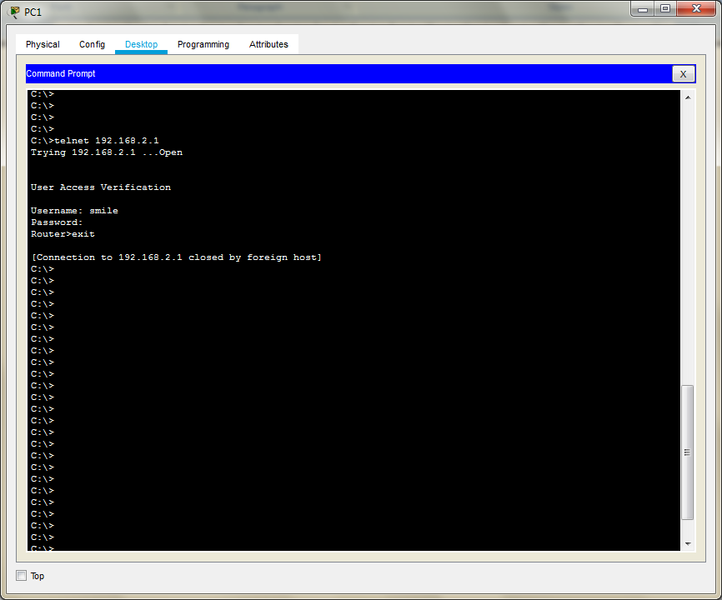

In order to authenticate the RADIUS server we need to turn OFF the TACACS service
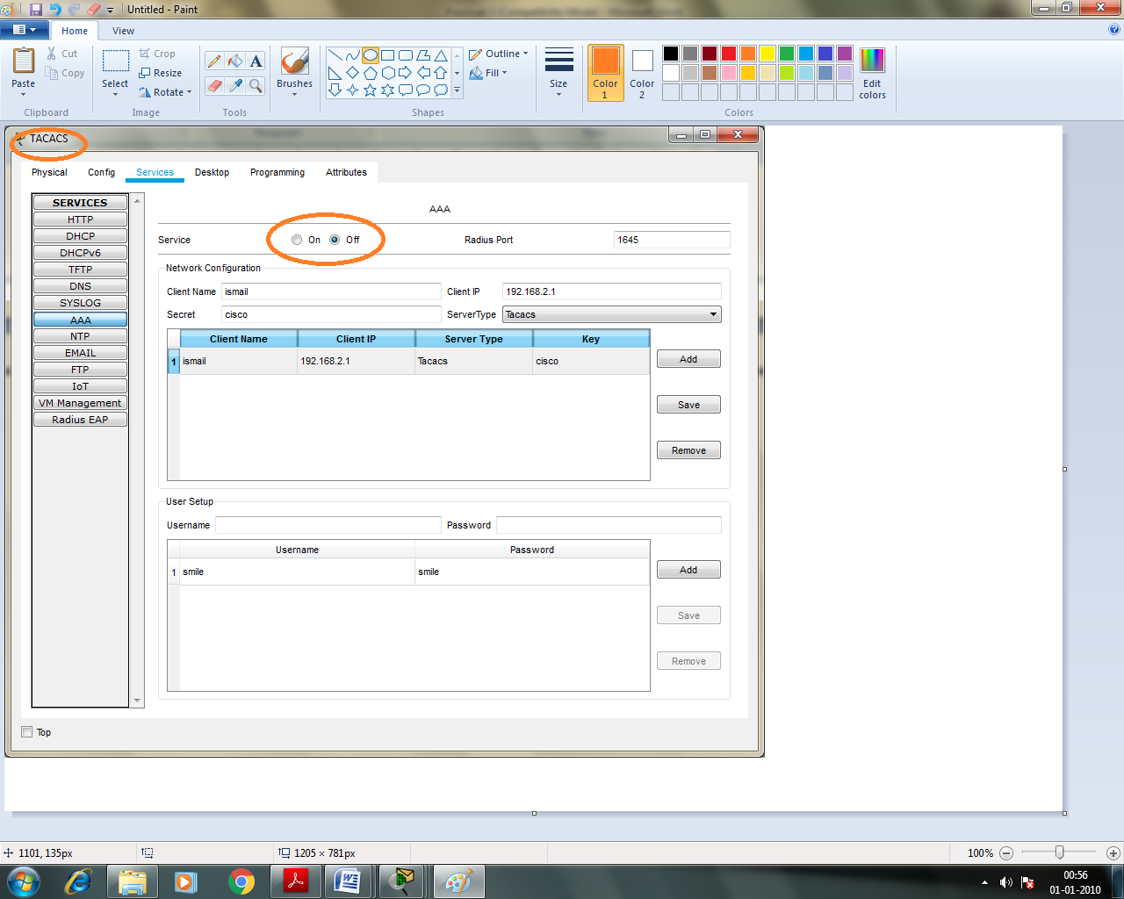
We again enter the command telnet 192.168.2.1 (the Router IP) and enter the username and password of the RADIUS server (Username: smile , Password: cisco)
We get the following

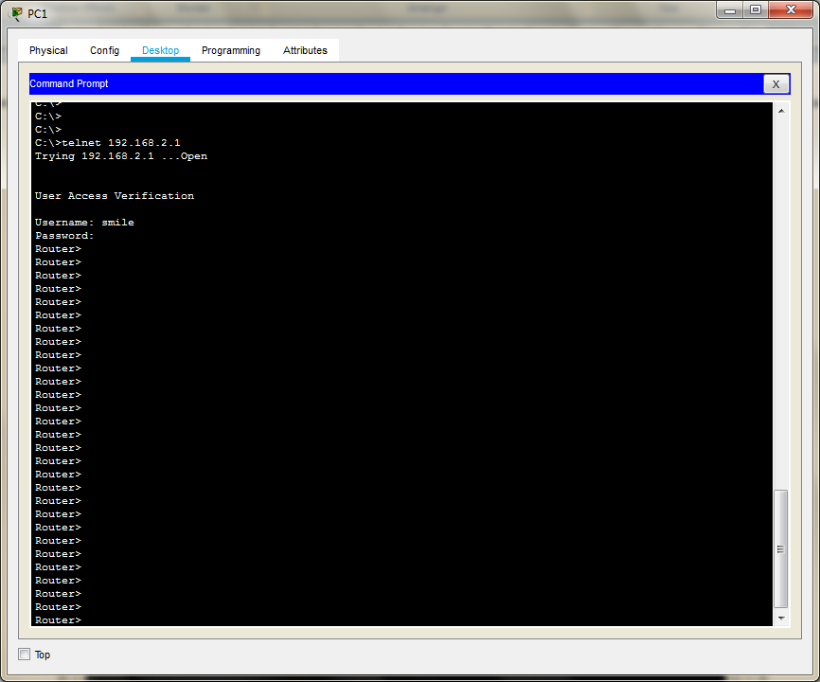

The local login can also be verified by turning OFF both TACACS and RADIUS service. The username and Password are both cisco (by default)
Hence the authentication through both TACACS and RADIUS

